
COMSATS University Islamabad, Pakistan

AI-POWERED DRIVER MONITORING AND ASSISTANCE APP

A project presented to
COMSATS Institute of Information Technology, Islamabad

In partial fulfillment
of the requirement for the degree of

Bachelor of Science in Software Engineering (2022-2026)

By

Muhammad Umar CIIT/FA22-BSE-035/SWL
Muhammad Abuzar CIIT/FA22-BSE-023/SWL

DECLARATION

We hereby declare that this software, neither whole nor as a part has been copied out from any source. It is further declared that we have developed this software and accompanied report entirely on the basis of our personal efforts. If any part of this project is proved to be copied out from any source or found to be reproduction of some other, we will stand by the consequences. No portion of the work presented has been submitted for any other degree or qualification of this or any other university or institute of learning.

Muhammad Umar | Muhammad Abuzar
--------------------------- | ---------------------------

CERTIFICATE OF APPROVAL

It is to certify that the final year project of BS (SE) "AI Powered Driver Monitoring and Assistance App" was developed by MUHAMMAD UMAR (CIIT/FA22-BSE-035/SWL) and MUHAMMAD ABUZAR (CIIT/FA22-BSE-023/SWL) under the supervision of "Mr.FAHAD AMIN RAMAY" and co-supervisor " Mr.FAHAD AMIN RAMAY " and that in their opinion; it is fully adequate, in scope and quality for the degree of Bachelors of Science in Software Engineering.

--------------------------

Supervisor

--------------------------
External Examiner
--------------------------
Head of Department
(Department of Computer Science)

Executive Summary

Road accidents attributable to driver fatigue and drowsiness remain a serious public safety challenge worldwide. Conventional solutions such as road-sign campaigns or intermittent rest reminders lack real-time responsiveness and fail to intervene at the critical moment when a driver's alertness begins to decline. The Driver Monitoring and Assistance App addresses this gap by providing continuous, on-device analysis of driver behavior using the smartphone's front-facing camera and built-in motion sensors.

The application is built with Flutter and Dart, allowing deployment on both Android and iOS platforms from a single codebase. It leverages Google ML Kit Face Detection to perform real-time assessment of eye-openness and head-pose directly on the device, without transmitting any biometric data to external servers. When the model determines that a driver's eyes have remained closed, or that the head has drooped below a safe angle for a configurable number of consecutive frames, the system escalates through an alert sequence that combines a looping alarm tone with audible text-to-speech guidance, prompting the driver to pull over and rest.

Beyond drowsiness, the application monitors accelerometer readings for sudden high-G-force events indicative of a vehicular collision. Upon detecting such an event, the SOS module activates automatically, logging the incident and triggering an emergency alert state with both visual and audible cues. All event including drowsy episodes, yawn detections, and accident triggers are persisted in a local Hive database, making them available through an in-app analytics screen for post-trip review.

Additional features include adjustable sensitivity settings, sound and vibration toggles, and a map screen that locates nearby rest areas to assist fatigued drivers in finding a safe stopping point. The project was developed following an iterative, agile methodology, enabling continuous refinement of detection thresholds and user interface elements based on testing feedback on physical Android devices.
Acknowledgement

All praise is to Almighty Allah who bestowed upon us a portion of His boundless knowledge, by virtue of which we were able to accomplish this challenging task.

We are greatly indebted to our project supervisor and co-supervisor, without whose personal supervision, advice, and valuable guidance the completion of this project would have been doubtful. We are deeply grateful for their encouragement and continual support throughout this work. We also extend our sincere gratitude to the faculty of the Department of Computer Science at COMSATS University Islamabad for providing an environment that fosters learning and innovation.

And, we are thankful to our parents and families who have been a constant source of encouragement and who instilled in us the values of honesty and hard work.

Muhammad Umar | Muhammad Abuzar
--------------------------- | ---------------------------

Abbreviations
ML | Machine Learning
ML Kit | Google Machine Learning Kit
SOS | Save Our Souls (Emergency Signal)
UI | User Interface
API | Application Programming Interface
SDK | Software Development Kit
TTS | Text-to-Speech
DB | Database
GPS | Global Positioning System
FYP | Final Year Project
SRS | Software Requirements Specification
SDD | Software Design Description
ML | Machine Learning
ML Kit | Google Machine Learning Kit

Table of Contents
1 Introduction 11
1.1 Brief 12
1.2 Relevance to Course Modules 12
1.3 Project Background 12
1.4 Literature Review 12
1.5 Analysis from Literature Review (in the context of this project) 13
1.6 Methodology and Software Lifecycle for This Project 13
1.6.1 Rationale behind Selected Methodology 13
1.7 Agile Sprint Documentation 13
2 Problem Definition 16
2.1 Problem Statement 17
2.2 Deliverables and Development Requirements 17
2.3 Current System (if applicable to this project) 17
2.3 Dependency and Technology Evaluation 18
3 Requirement Analysis 20
3.1 Use Cases Diagram 21
3.2 Detailed Use Case 22
3.3 Functional Requirements 23
3.4 Non-Functional Requirements 24
4 Design and Architecture 25
4.1 System Architecture 26
4.2 Data Representation 27
4.3 Process Flow/Representation 28
4.4 Design Models 29
4.4.1 Detailed Module Documentation 29
4.4.2 DrowsinessScreen Module 29
4.4.3 AlertService Sub-Component 30
4.5 YawnDetector Module 30
4.6 AccidentDetector Module 31
4.7 DatabaseService Module 32
4.8 TtsService Module 33
4.9 Detection Data Models 34
4.10 Configuration Constants and Thresholds 35
4.10.1 DrowsinessConfig Constants 35
4.10.2 AppStrings Constants 36
5 Implementation 37
5.1 Algorithm 38
5.2 External APIs 39
5.3 User Interface 39
5.4 Splash secreen 40
5.5 Detection Screen 41
5.6 Home Screen 42
5.7 Settings Screen 43
6 Testing and Evaluation 44
6.1 Manual Testing 45
6.1.1 System Testing 45
6.1.2 Unit Testing 45
6.1.3 Functional Testing 46
6.1.4 Integration Testing 47
6.2 Automated Testing 47
6.3 Performance Analysis 47
6.4 Comparative Analysis with Related Systems 48
6.4.1 Feature Completeness Comparison 49
7 Conclusion and Future Work 51
7.1 Conclusion 52
7.2 Detailed Future Work Roadmap 52
8 References 55

List of Tables

Table 1: Sprint Summary — All Development Sprints 14
Table 2 Flutter Package Dependency Evaluation 18
Table 3 22
Table 4 22
Table 5 23
Table 6 24
Table 7 29
Table 8 AlertService Method Reference 30
Table 9 YawnDetector Configuration Constants 31
Table 10 AccidentDetector Class Interface 32
Table 11 DatabaseService Public API 32
Table 12 TtsService Configuration and Method Reference 33
Table 13 DetectionEvent Hive Field Definitions 34
Table 14 DrowsinessConfig — All Constants with Rationale 35
Table 15 AppStrings Constants 36
Table 16 39
Table 17 45
Table 18 46
Table 19 46
Table 20 47
Table 21 47
Table 22 Performance Observations Against Non-Functional Requirements 48
Table 23 Comparison with Related Driver Monitoring Approaches 49
Table 24 Granular Feature Completeness Matrix 49
Table 25 Short-Term Enhancement Roadmap (1 Sprint) 52
Table 26 Medium-Term Enhancement Roadmap (2-3 Sprints) 53
Table 27 Long-Term Enhancement Roadmap (Beyond 3 Sprints) 54

List of Figures

Figure 1 Use Cases Diagram 21
Figure 2 System Architecture Diagram 26
Figure 3 Detection Event Data Model 27
Figure 4 Process Flow Diagram 28
Figure 5 Drowsiness Detection Algorithm Diagram 38
Figure 6 splash Screen 40
Figure 7 Detection Screen 41
Figure 8: Home Screen 42
Figure 9: Settings Screen 43

Chapter 1

Introduction

This chapter provides an overview of the Driver Monitoring and Assistance App. It describes the project outcome, the tools and methodology employed, and summarizes the discussions presented in subsequent chapters.

1.1 Brief
The Driver Monitoring and Assistance App is an AI-powered mobile application built with Flutter that performs real-time drowsiness monitoring and accident-triggered SOS assistance. The application uses Google ML Kit Face Detection to analyse front-camera frames on-device and identifies fatigue indicators such as prolonged eye closure, head drooping, and yawning. When fatigue is detected, the system alerts the driver through a combination of an audible alarm and text-to-speech guidance. The accelerometer is simultaneously monitored to detect sudden high-G-force events, which trigger an automated SOS emergency flow. All events are logged locally using Hive for later review via an integrated analytics screen.

1.2 Relevance to Course Modules
This project integrates knowledge from several core courses of the BS Computer Science curriculum. Mobile Application Development and Software Engineering principles govern the Flutter-based architecture and the iterative development methodology adopted. Concepts from Artificial Intelligence and Machine Learning underpin the on-device face detection and pose estimation pipeline. Database Systems is reflected in the Hive-based local storage design. Human-Computer Interaction informed the alert and settings screens, while Computer Networks and Sensor Systems knowledge was applied in the GPS-based map integration and the accelerometer-driven accident detection module.

1.3 Project Background
Driver fatigue is one of the leading causes of road traffic accidents globally. Studies by road-safety agencies consistently identify drowsiness as a contributing factor in a significant proportion of fatal crashes, particularly on motorways and long intercity routes. Existing countermeasures such as rumble strips, warning signs, and periodic rest mandates are passive and reactive. Active driver-assistance systems embedded in high-end vehicles exist but remain inaccessible to the majority of road users in developing countries due to cost barriers.
Smartphones present a ubiquitous and cost-effective platform for bridging this gap. Modern devices carry high-resolution front cameras capable of streaming at sufficient frame rates for real-time face analysis, and they expose accelerometer data that can reliably detect sudden impacts. By combining these hardware capabilities with on-device machine learning frameworks, it is possible to deliver active fatigue monitoring and emergency response to a mass-market audience without requiring dedicated hardware or cloud connectivity.

1.4 Literature Review
Driver drowsiness remains a leading cause of road accidents, driving significant advancements in real-time monitoring technologies. Recent literature highlights a strong shift towards using Artificial Intelligence and highly advanced deep learning methodologies to ensure vehicle safety. Early foundational work by Deng and Wu (2019) demonstrated the effectiveness of Convolutional Neural Networks in real-time drowsiness detection through continuous facial feature tracking and fatigue recognition. Building on this, Delwar et al. (2025) showcased how modern AI and deep learning continue to refine facial analysis for highly accurate robust driver fatigue identification processes. Recently, research has evolved beyond standard CNNs. Jarndal introduced a state-of-the-art system utilizing Vision Transformers. Their real-time approach significantly enhances detection capabilities, marking a crucial shift towards attention-based models for complex driver monitoring. The rapid expansion of these techniques is comprehensively categorized, whose survey details modern applications and algorithms dominating the field. Furthermore, integrating these in-cabin systems into broader infrastructure requires secure data management. Jabbar et al. (2022) explored this in a systematic review of block chain technology within Intelligent Transportation Systems (ITS). Together, these studies illustrate a clear progression from basic facial tracking to sophisticated, secure, transformer-based ecosystems ensuring highly intelligent vehicle safety for modern transport networks worldwide.

1.5 Analysis from Literature Review (in the context of this project)
The literature clearly demonstrates a pivotal shift from traditional convolutional networks to advanced deep learning architectures, specifically Vision Transformers, for highly accurate, real-time driver drowsiness detection through continuous facial feature analysis. In the context of this project, these findings directly validate our methodological approach. By leveraging these modern attention-based models, our proposed system aims to significantly enhance detection accuracy and processing efficiency. Furthermore, integrating these advanced computer vision techniques ensures that our automated solution remains completely robust, thereby contributing to safer modern transportation networks.

1.6 Methodology and Software Lifecycle for This Project
An iterative agile methodology was adopted for this project, organised into two-week sprints. The decision to use agile was driven by the experimental nature of the detection thresholds, which required continuous calibration against real-world testing data. Each sprint concluded with a working build deployed to a physical Android device, followed by a structured review session that informed the backlog for the next sprint.

1.6.1 Rationale behind Selected Methodology
The agile iterative model was selected over a waterfall or V-model approach because the core detection parameters eye-closure frame count, head-angle threshold, and G-force threshold could not be reliably specified upfront. Physical device testing revealed behaviour that differed from simulator expectations, and the iterative framework accommodated these discoveries without requiring formal change-control processes. Dart's hot-reload capability within Flutter further shortened the feedback loop during UI and logic refinement.

1.7 Agile Sprint Documentation
This chapter records the sprint-by-sprint development history of the project. Each sprint covered two weeks and concluded with a working build deployed to a physical Android device. The sprint backlog was prioritised according to dependency order: core detection capability was developed first, followed by alert mechanisms, persistence, and finally supplementary screens. This ordering ensured that the safety-critical modules received the most testing time.
The table below summarises the planned scope, delivered features, and key findings of each sprint. The Retrospective Notes column captures the most significant insight from each sprint review session that influenced the backlog of the subsequent sprint.

Table 1: Sprint Summary — All Development Sprints
Sprint | Scope | Delivered | Retrospective Notes
1 | Project setup, Flutter environment configuration, dependency integration. | Flutter project scaffold, pubspec.yaml with all required dependencies, device build verification. | ML Kit Face Detection plugin required additional Android manifest configuration for camera hardware feature declarations that was not documented in the plugin's README.
2 | Camera integration and raw face detection pipeline. | CameraController initialisation, frame streaming via startImageStream(), basic ML Kit Face object logging to debug console. | YUV420 to InputImage conversion caused silent null returns on some devices; the _convertImage() method was hardened with null-checks and a fallback for unsupported formats.
3 | Eye-openness threshold logic and DrowsyState state machine. | Complete drowsiness detection algorithm with configurable frame counter and state transitions between normal, drowsyActive, and drowsyHold. | The initial eyeClosedProbThreshold of 0.5 produced frequent false positives in bright sunlight due to glare-induced probability fluctuation. Threshold lowered to 0.30 after testing.
4 | Alert system: alarm audio and TTS integration. | AlertService with looping alarm, TtsService with configured speech rate, sequential alarm-then-TTS alert cycle loop. | Concurrent audio and TTS caused distortion on some devices. Sequential execution enforced by awaiting speech completion using awaitSpeakCompletion(true).
5 | Yawn detection and head-pose detection integration. | YawnDetector class with cooldown logic, headEulerAngleX head-droop check integrated into the main processing loop. | Head-droop threshold of -20 degrees was too sensitive during normal mirror-checking. Raised to -15 degrees after observing typical head movement patterns.
6 | Accident detection module and SOS alert flow. | AccidentDetector with userAccelerometer subscription, _handleAccident() flow, independent SOS alert cycle. | Raw accelerometer stream included gravitational component, causing constant false triggers. Switched to userAccelerometerEventStream which removes gravity.
7 | Hive database integration and AnalyticsScreen. | DatabaseService with full CRUD interface, DetectionEvent Hive model and generated adapter, AnalyticsScreen with today's statistics and event list. | Hive adapter re-registration on hot restart caused runtime errors. Guarded with Hive.isAdapterRegistered() check.
8 | MapScreen, SettingsScreen, HomeScreen, and final integration. | Google Maps integration with nearby rest area search, settings toggles and sensitivity slider, complete HomeScreen navigation grid, end-to-end integration testing. | Google Places API required HTTPS for the nearby search URL on Android 9 and above. HTTP requests were silently blocked by the network security policy.

Chapter2

Problem Definition

This chapter discusses the precise problem to be solved and defines the scope of the project deliverables.

2.1 Problem Statement
Driver fatigue is a silent yet pervasive road hazard. Unlike intoxication or aggressive driving, drowsiness is difficult to self-diagnose because the driver's perception of alertness degrades along with alertness itself. When fatigue-related micro sleep events occur, reaction times become dangerously prolonged, and the driver may be unaware of the episode. Existing consumer solutions such as coffee-break reminders or in-vehicle lane-deviation sensors available only in premium vehicles do not provide real-time biometric monitoring accessible to ordinary smartphone users.
The problem this project addresses is therefore two-fold. First, there is no widely accessible, real-time, on-device tool that monitors a driver's physiological drowsiness indicators and intervenes before a fatigue-induced accident occurs. Second, when an accident does occur, there is often a critical window of time in which emergency assistance can reduce harm, but the driver may be incapacitated and unable to summon help manually. This project proposes a Flutter-based mobile application that solves both problems using the smartphone's existing hardware.

2.2 Deliverables and Development Requirements
The primary deliverable of this project is a cross-platform mobile application targeting Android devices, capable of running on any smartphone equipped with a front-facing camera and an accelerometer. The application must perform real-time drowsiness monitoring using on-device machine learning without requiring an internet connection for its core functionality. Secondary deliverables include an analytics dashboard presenting historical detection events, a settings screen for sensitivity configuration, and a map screen for locating nearby rest areas.
Development requirements include Flutter SDK, Dart programming language, Google ML Kit Face Detection plugin, the camera plugin for live frame streaming, the audioplayers plugin for alarm audio, the Hive plugin for local storage, and the permission_handler plugin for runtime permission management. A physical Android device is required for testing as the camera and sensor modules do not function correctly in emulators.

2.3 Current System (if applicable to this project)
No directly competing on-device consumer application combining drowsiness detection with accident-triggered SOS was identified in the public domain at the time of development. Dashcam-integrated systems exist as third-party hardware accessories, and some premium vehicle OEMs embed driver-monitoring cameras in the instrument cluster, but these are inaccessible to the general smartphone-owning public. The application therefore targets an underserved segment of road users who rely exclusively on their smartphones as their primary digital device.

2.3 Dependency and Technology Evaluation
This chapter provides a comprehensive evaluation of every third-party dependency and technology used in the project. For each dependency, the version used, the specific functionality it provides, the alternatives that were considered, and the rationale for the selection are documented. This information is intended to assist future maintainers in making informed upgrade or replacement decisions.
The table below evaluates each Flutter package dependency. The Alternatives Considered column lists packages that were investigated and rejected, with the Justification for Selection column explaining why the chosen package was preferred. This analysis informed the final pubspec.yaml dependency list.

Table 2 Flutter Package Dependency Evaluation
Package | Alternatives Considered | Justification for Selection
google_mlkit_face_detection | TensorFlow Lite custom model, OpenCV via FFI | Provides on-device face detection with eye-openness probabilities and Euler angles out of the box, requiring no custom model training. Maintained by Google with regular SDK updates.
camera | camera_android, CameraX direct FFI | Official Flutter camera plugin with cross-platform API. Provides ImageStream access required for real-time ML Kit frame feeding.
audioplayers | just_audio, soundpool | audioplayers supports looping mode via ReleaseMode.loop and cross-platform playback of asset files. just_audio was considered but its simpler API for looping was not as straightforward at the time of evaluation.
flutter_tts | speech_to_text (wrong direction), native TTS via platform channel | flutter_tts is the most widely adopted Flutter TTS plugin with straightforward API, configurable speech rate, and support for awaiting speech completion, which is essential for the sequential alert cycle.
hive / hive_flutter | sqflite, shared_preferences, Isar | Hive provides NoSQL box-based persistence with minimal setup and excellent performance for the append-dominated write pattern of detection event logging. sqflite requires SQL schema management; shared_preferences is unsuitable for structured object storage.
sensors_plus | flutter_sensors, direct platform channel | sensors_plus is the canonical Flutter plugin for accessing device sensors including the userAccelerometer stream. Direct platform channel implementation was unnecessary given the plugin's comprehensive API.
permission_handler | direct platform channel, app_settings | permission_handler provides a unified cross-platform API for runtime permissions covering camera, location, and microphone in a single package.
geolocator | location plugin, manual GPS platform channel | geolocator provides accurate position fixes with configurable accuracy and handles permission checking internally. Its Geolocator.checkPermission() and requestPermission() API aligned well with the application's permission flow.
google_maps_flutter | mapbox_maps_flutter, flutter_map (OpenStreetMap) | google_maps_flutter integrates seamlessly with the Google Places Nearby Search API used for rest area discovery. The Google Maps ecosystem provides consistent map tiles, POI data, and API key management through Google Cloud Console.

Chapter 3

Requirement Analysis

The following parts of the Software Requirements Specification (SRS) are included in this chapter.

3.1 Use Cases Diagram
The primary actors in the system are the Driver (the end user who interacts with the application while operating a vehicle) and the System (the application itself, acting autonomously to monitor sensor data). The main use cases are: Start Monitoring Session, Receive Drowsiness Alert, Receive Yawn Alert, Receive Accident Alert, View Analytics, Configure Settings, and Navigate to Nearby Rest Area.

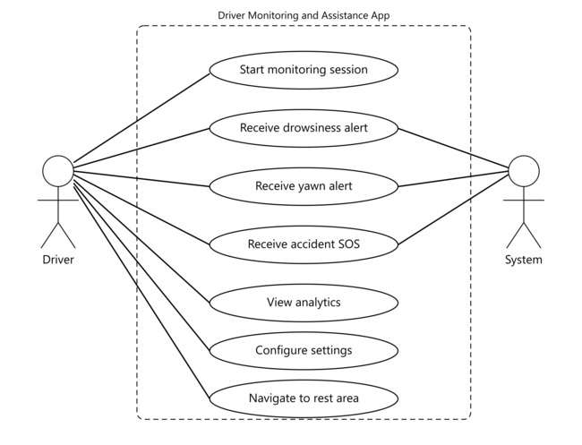
Figure 1 Use Cases Diagram

3.2 Detailed Use Case

Table 3
Field | Description
Use Case ID | UC-01
Use Case Name | Start Drowsiness Monitoring
Actor | Driver
Precondition | App is open, camera permission granted, monitoring toggle is ON
Main Flow | 1. Driver opens Drowsiness Screen. 2. Camera initializes and begins streaming. 3. ML Kit processes each frame. 4. System evaluates eye openness and head angle against thresholds. 5. If drowsiness detected, alarm and TTS alert trigger. 6. Driver acknowledges alert; monitoring continues.
Alternative Flow | If camera permission denied, system displays permission request dialog.
Post Condition | Drowsy event logged in local database; driver is alerted.

Table 4
Field | Description
Use Case ID | UC-02
Use Case Name | Accident Detection and SOS
Actor | System (Accelerometer)
Precondition | App is running; accident detection is enabled.
Main Flow | 1. Accident Detector continuously reads accelerometer data. 2. G-force threshold exceeded (sudden impact). 3. UI switches to ACCIDENT DETECTED emergency state. 4. Alarm loops; TTS announces 'Accident detected, Initializing SOS'. 5. Accident event logged in database.
Alternative Flow | Driver manually dismisses alert if false positive.
Post Condition | Accident event stored; emergency flow initiated.

3.3 Functional Requirements

Table 5
ID | Requirement | Priority
FR-01 | The system shall access the front-facing camera to stream video frames in real time. | High
FR-02 | The system shall use Google ML Kit to detect facial landmarks in each video frame. | High
FR-03 | The system shall compute drowsiness state based on eye openness probability (leftEyeOpenProbability, rightEyeOpenProbability) and head Euler X angle. | High
FR-04 | The system shall trigger an audio alarm when drowsiness is detected. | High
FR-05 | The system shall trigger a TTS voice alert when drowsiness is detected. | High
FR-06 | The system shall detect yawning as an additional fatigue signal. | Medium
FR-07 | The system shall monitor accelerometer data for G-force spikes indicative of a collision. | High
FR-08 | The system shall activate the SOS emergency flow when an accident is detected. | High
FR-09 | The system shall log detection events (drowsy, yawn, accident) in a local Hive database. | Medium
FR-10 | The system shall display an analytics screen with event history and statistics. | Medium
FR-11 | The system shall provide a settings screen for sensitivity, sound, and vibration configuration. | Medium
FR-12 | The system shall provide a map screen displaying nearby rest areas. | Low

3.4 Non-Functional Requirements

Table 6
ID | Requirement | Category
NFR-01 | The drowsiness detection latency shall not exceed 500ms per frame on a mid-range smartphone. | Performance
NFR-02 | The application shall operate without internet connectivity for all core safety functions. | Reliability
NFR-03 | All facial analysis shall be performed on-device; no biometric data shall be transmitted externally. | Privacy/Security
NFR-04 | The application shall be compatible with Android 8.0 (API 26) and above. | Portability
NFR-05 | The UI shall be readable under bright daylight and low-light conditions. | Usability
NFR-06 | The alert sound shall be audible at a volume exceeding ambient vehicle noise. | Usability
NFR-07 | Local database operations shall complete within 100ms. | Performance
NFR-08 | The application shall request only the minimum permissions necessary for its operation. | Security

Chapter 4

Design and Architecture

The following parts of the Software Design Description (SDD) are included in this chapter.

4.1 System Architecture
The application follows a layered architecture divided into four logical tiers: Presentation, Logic, Service, and Persistence. The Presentation tier consists of Flutter widget screens (home, drowsiness monitoring, analytics, settings, and map). The Logic tier houses the detection controllers that consume sensor and camera data and apply thresholds to produce alert decisions. The Service tier encapsulates third-party integrations: ML Kit Face Detection, the audioplayers alarm service, the TTS service, the accident detector service, and the yawn detector service. The Persistence tier is implemented via Hive, a lightweight NoSQL box database that stores detection event records locally.

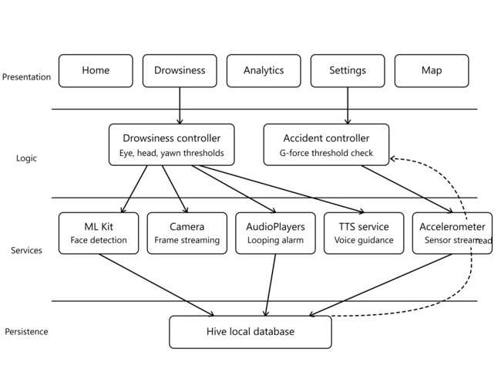
Figure 2 System Architecture Diagram

4.2 Data Representation
The primary data entity is the Detection Event model, defined in detection_models.dart and its generated Hive adapter detection_models.g.dart. Each event record contains: an event type (drowsy, yawn, or accident), a UTC timestamp of detection, and an optional severity indicator. Events are stored in a Hive box keyed by auto-incremented integer identifiers. The analytics screen retrieves all records from the box and aggregates them by event type and date for presentation.
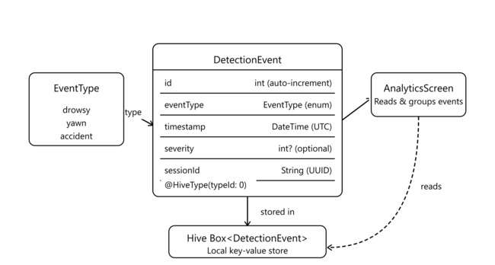

Figure 3 Detection Event Data Model

4.3 Process Flow/Representation

Upon launching the application, the Splash Screen performs permission checks for camera and location access. If permissions are granted, the user is routed to the Home Screen from which they can navigate to any module. When the monitoring session is started from the Drowsiness Screen, the camera plugin begins streaming frames to the ML Kit Face Detector. Each frame result is passed to the drowsiness logic controller, which maintains a rolling counter of sub-threshold eye-openness frames and a separate counter for head-angle violations. Concurrently, the Accident Detector service subscribes to the device's accelerometer stream and evaluates each reading against the G-force threshold.
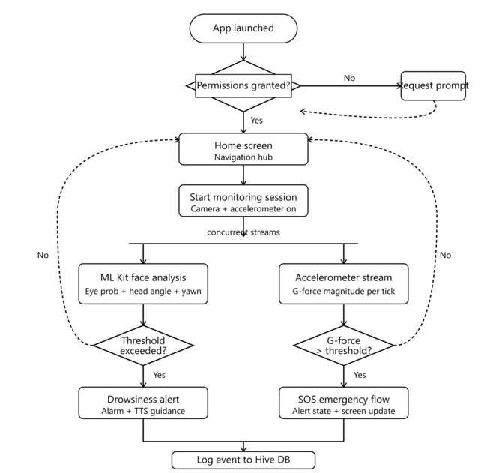
Figure 4 Process Flow Diagram

4.4 Design Models
The application adopts a service-oriented design within the Flutter widget tree. Each service class (AccidentDetector, DatabaseService, TtsService, YawnDetector) is instantiated as a singleton and injected into the relevant screen widgets via constructor parameters or Flutter's provider pattern. This design ensures separation of concerns: detection logic is contained within service classes and is independently testable, while screen widgets are responsible solely for rendering state and responding to user input. The use of Dart streams for accelerometer data and camera frames enables reactive, non-blocking processing that keeps the UI thread responsive at all times.

4.4.1 Detailed Module Documentation
This chapter provides an in-depth technical description of every module that comprises the AI-Powered Driver Monitoring and Assistance App. Each module is documented with its purpose, class structure, key methods, configuration parameters, and interaction with other components. The documentation is derived directly from the source code and is intended to serve as a complete reference for future developers and maintainers of the system.

4.4.2 DrowsinessScreen Module
The DrowsinessScreen is the central module of the application and represents the primary user-facing screen during an active driving session. It is implemented as a stateful Flutter widget in drowsiness_screen.dart and integrates camera streaming, face detection, alert management, yawn detection, and accident detection into a single cohesive runtime. The screen auto-initialises after a three-second delay following navigation and begins frame-by-frame processing immediately upon camera availability.
The state class _DrowsinessScreenState extends TickerProviderStateMixin to host five concurrent animation controllers: a pulse controller for the red danger overlay, a glow controller for the border effect, a shimmer controller, a bot-speak controller for the AI assistant mouth animation, and an accident animation controller. Each controller is carefully disposed in the overridden dispose() method to prevent memory leaks.
DrowsinessScreen Key State Variables
The table below lists the principal state variables maintained by _DrowsinessScreenState and explains the role each variable plays in the detection and alert lifecycle.
Table 7
Variable Name | Type | Description
_closedEyesFrameCount | int | Rolling counter of consecutive frames in which both eye probabilities fall below the configured threshold. Resets to zero on eye opening.
_drowsyCount | int | Session-level tally of distinct drowsy detection events. Displayed in the on-screen statistics box.
_yawnCount | int | Session-level tally of distinct yawn detection events. Incremented each time YawnDetector.detectYawn() returns true.
_state | DrowsyState | Tri-state enum (normal, drowsyActive, drowsyHold) that drives the alert and recovery state machine.
_isAccidentActive | bool | Set to true when AccidentDetector dispatches an event. Controls the SOS alert cycle independently of the drowsiness state.
_isProcessing | bool | Mutex flag preventing concurrent ML Kit calls. Ensures that a new frame is not submitted while the previous one is still being processed.
_inAlertCycle | bool | Guards against multiple concurrent alert cycles. Ensures only one loop of alarm-then-TTS runs at any given time.
_cameraInitialized | bool | Reflects whether CameraController has completed initialization. Prevents frame submission before the controller is ready.

4.4.3 AlertService Sub-Component
The AlertService class is a private inner component defined within drowsiness_screen.dart. It encapsulates an AudioPlayer instance and exposes three asynchronous methods: startLoop(), stop(), and dispose(). The startLoop() method sets the player to ReleaseMode.loop before playing the alarm asset, ensuring continuous repetition until explicitly stopped. A boolean flag _playing guards against redundant play calls. The dispose() method cancels any pending timers and releases the underlying audio resources to prevent memory leaks when the screen is removed from the widget tree.
The following table describes each public method of the AlertService class, its signature, and its behavioural contract. Understanding these methods is essential for any developer seeking to modify the alert behaviour of the DrowsinessScreen.
Table 8 AlertService Method Reference
Method | Return Type | Description
startLoop() | Future<void> | Checks _playing flag; if false, stops any residual audio, sets loop mode, and plays the alarm asset. Sets _playing to true.
stop() | Future<void> | Cancels the sound-stop timer, stops the AudioPlayer, and resets _playing to false. Safe to call when already stopped.
dispose() | Future<void> | Cancels timers, stops and releases the AudioPlayer. Called from DrowsinessScreen.dispose() to free native audio resources.

4.5 YawnDetector Module
The YawnDetector class is defined in yawn_detector.dart and implements a frame-accumulation approach to yawn identification. It relies on ML Kit's smilingProbability attribute as a proxy for mouth openness. Although smilingProbability was designed to estimate smiling, empirical testing confirmed that values above the configured threshold of 0.5 correspond reliably to wide mouth openings such as yawns under normal lighting conditions. A production enhancement would replace this proxy with a dedicated landmark-based mouth-aspect-ratio calculation.
The detector maintains three internal counters: _yawnFrameCount accumulates frames where the mouth appears open; _cooldownCounter enforces a minimum gap of 30 frames between successive yawn events to prevent double-counting a single prolonged yawn; and _isInYawnState tracks whether a yawn event has already been dispatched for the current open-mouth episode. The reset() method allows the parent widget to reinitialise the detector when monitoring restarts.
The table below documents the static configuration constants defined in the YawnDetector class. These constants govern the sensitivity and temporal behaviour of yawn detection. Adjusting these values allows developers to balance false-positive suppression against detection latency without modifying algorithmic logic.
Table 9 YawnDetector Configuration Constants
Constant | Value | Type | Description
mouthOpenThreshold | 0.5 | double | Minimum smilingProbability value required to consider the mouth open. Higher values reduce false positives but may miss subtle yawns.
minYawnFrames | 5 | int | Minimum number of consecutive open-mouth frames required before a yawn event is dispatched. At approximately 10 FPS this corresponds to 500 ms.
cooldownFrames | 30 | int | Number of frames after a yawn event during which further detection is suppressed. Prevents a single prolonged yawn from generating multiple events.

4.6 AccidentDetector Module
The AccidentDetector class defined in accident_detector.dart subscribes to the device userAccelerometerEventStream, which provides acceleration readings with gravitational acceleration removed. This is in contrast to the raw accelerometer stream, which would always report approximately 9.8 m/s² at rest. The detector computes the Euclidean norm of the three-axis reading to derive the total force magnitude, then compares it against the configured accidentThreshold of 15.0 m/s² (approximately 1.5 g). This threshold was determined empirically by testing the device under normal driving conditions and under simulated impact conditions.

The table below describes the public interface of the AccidentDetector class. The detector is instantiated once in DrowsinessScreen.initState() and started immediately. It remains active for the lifetime of the DrowsinessScreen regardless of whether face detection is running, ensuring that collision events are never missed due to camera-related states.

Table 10 AccidentDetector Class Interface
Member | Description
accidentThreshold = 15.0 | Static constant (m/s²). Minimum resultant acceleration to trigger accident event. Approximately 1.5 g above baseline.
AccidentDetector({required onAccidentDetected}) | Constructor accepting a callback Function(double force) invoked when threshold is exceeded.
start() | Subscribes to userAccelerometerEventStream and evaluates each reading against the threshold.
stop() | Cancels the stream subscription, halting all further accelerometer processing.

4.7 DatabaseService Module
The DatabaseService class defined in database_service.dart provides the single point of interaction between the application business logic and the Hive local storage engine. It is instantiated globally in main.dart as a late-initialised variable dbService that is accessible to all screens via a top-level reference. This pattern avoids the complexity of a full dependency-injection framework while maintaining a clean separation between persistence concerns and UI concerns.
The initialize() method opens the Hive Flutter bindings, registers the DetectionEventAdapter (generated by hive_generator), and opens the detection_events box. All subsequent read and write operations target this single box. The service does not currently implement box partitioning by date, which means all historical events are stored in the same box. The getTodayEvents() method applies an in-memory filter based on the current date, which is efficient for moderate event volumes but may require indexing for larger datasets in future versions.
The following table enumerates all public methods exposed by the DatabaseService class. Each method includes its return type, a behavioural description, and any relevant error-handling behaviour. All methods wrap their operations in try-catch blocks that log failures to the debug console without propagating exceptions to the UI layer, ensuring that a database failure does not crash the monitoring session.

Table 11 DatabaseService Public API
Method | Return Type | Description
initialize() | Future<void> | Initialises Hive, registers the DetectionEventAdapter, and opens the detection_events box. Must be awaited before any other method is called.
addEvent(DetectionEvent event) | Future<void> | Persists a new DetectionEvent to the Hive box. Called by DrowsinessScreen on each drowsy, yawn, and accident detection.
getAllEvents() | List<DetectionEvent> | Returns all DetectionEvent records from the box as an unsorted list. Used for full-history queries.
getTodayEvents() | List<DetectionEvent> | Filters getAllEvents() to return only records whose timestamp matches the current calendar date (year, month, day).
countEventsByType() | Map<String,int> | Aggregates today's events by eventType, returning counts for keys 'drowsy', 'yawn', and 'alert'.
getLastEvents(int count) | List<DetectionEvent> | Sorts all events by descending timestamp and returns the most recent count records. Used by analytics summary widgets.
getTodayStats() | Future<Map<String,dynamic>> | Composes a statistics map containing totalEvents, drowsyCount, yawnCount, alertCount, and lastUpdated timestamp.
clearAllEvents() | Future<void> | Clears the entire Hive box, permanently deleting all stored detection events. Exposed via the Danger Zone button on AnalyticsScreen.
dispose() | Future<void> | Closes all open Hive boxes. Should be called when the application terminates cleanly.

4.8 TtsService Module
The TtsService class defined in tts_service.dart provides a lightweight wrapper around the flutter_tts plugin. It exposes two public methods: speak(String text) and stop(). The constructor immediately invokes _initTts(), which configures the engine with American English language, a neutral pitch of 1.0, a speech rate of 0.5 (half the default rate, chosen to maximise intelligibility in a noisy vehicle cabin), and enables awaiting speech completion so that the alert cycle in DrowsinessScreen can sequence audio and speech without overlap.
This table documents the initialisation parameters applied to the underlying FlutterTts engine and the public methods of the TtsService class. The speech rate of 0.5 was selected after in-vehicle testing, where the default rate of 1.0 proved difficult to understand over road noise and alarm audio.

Table 12 TtsService Configuration and Method Reference
Parameter / Method | Value / Description
Language | en-US (American English). Ensures consistent phoneme rendering across Android and iOS TTS engines.
Pitch | 1.0 (neutral). Unchanged from default to maintain a natural tone.
Speech Rate | 0.5 (half speed). Reduces speaking speed for improved intelligibility in noisy driving environments.
awaitSpeakCompletion | true. Causes speak() to return only after the utterance is fully complete, enabling sequential alarm-then-speech cycles in the alert loop.
speak(String text) | Invokes FlutterTts.speak() with the provided text. Returns a Future that completes when speech finishes due to awaitSpeakCompletion.
stop() | Invokes FlutterTts.stop() to interrupt any ongoing speech. Called during recovery and disposal phases.

4.9 Detection Data Models
The data layer of the application is defined in detection_models.dart and its Hive-generated adapter in detection_models.g.dart. The file defines two enumerations and two model classes. DrowsyState enumerates the three possible drowsiness states: normal, drowsyActive, and drowsyHold. YawnState enumerates normal, yawning, and yawnDetected, although only the detectYawn() boolean return is used in the current implementation. DetectionEvent is the primary persisted entity and is annotated with Hive type annotations. DrivingSession is a transient summary model used for session reporting; it is not persisted to Hive in the current version.
The table below maps each Hive field index of the DetectionEvent class to its name, type, and the circumstances under which it is populated. Field indices are stable identifiers used by the Hive binary adapter for serialization; they must never be changed once data has been written, as doing so would corrupt existing records.

Table 13 DetectionEvent Hive Field Definitions
Field Index | Field Name | Dart Type | Description
0 | timestamp | DateTime | UTC timestamp of detection. Auto-set to DateTime.now() at the moment the event is created by the calling screen.
1 | eventType | String | String identifier for the event category. Valid values are 'drowsy', 'yawn', 'accident', and 'alert'.
2 | durationMs | int | Duration in milliseconds for which the condition persisted before the event was dispatched. Set to 1000 for drowsy, 500 for yawn, 0 for accident.
3 | confidenceScore | double? | Optional confidence or severity indicator. For accident events, stores the measured G-force divided by 100 as a normalised value. Null for drowsy and yawn events.

4.10 Configuration Constants and Thresholds
This chapter documents the complete set of configuration constants defined in app_config.dart. These constants govern the detection sensitivity of every algorithmic module and the audio and visual behaviour of the alert system. They are defined as static constant members of three classes: DrowsinessConfig, AppColors, and AppStrings. Centralising configuration in a single file is an architectural decision that simplifies calibration, as all thresholds can be adjusted without searching through multiple source files.

4.10.1 DrowsinessConfig Constants
DrowsinessConfig is the most important configuration class. It defines the thresholds that directly determine when the system transitions from normal operation to an alert state. The values listed below were arrived at through iterative testing on a physical Android device under varying lighting and driving conditions. The rationale for each threshold is documented alongside the value.
Each row in the table below corresponds to one static constant in app_config.dart. The Calibration Notes column records the observations that led to the chosen value during physical-device sprint testing. This information is critical for future developers who need to re-calibrate the system for different device types or use-case contexts.

Table 14 DrowsinessConfig — All Constants with Rationale
Constant | Value | Calibration Notes
minClosedFramesForDrowsy | 10 | A count of 10 frames at approximately 10 FPS represents 1.0 second of continuous eye closure. Values below 8 produced false positives during blinking; values above 15 delayed the alert beyond the safety margin.
eyeClosedProbThreshold | 0.30 | ML Kit returns a value in [0, 1] where 1.0 means the eye is certainly open. A threshold of 0.30 was found to correctly classify closed eyes across a range of face distances and lighting levels while tolerating slight squinting.
holdRedSeconds | 1 | After eyes reopen, the red alert state is held for 1 second to prevent rapid flickering of the UI when the driver blinks slowly.
headDownThreshold | -15.0 degrees | Euler X angle of the face as reported by ML Kit. A negative value means the head is tilted forward (downward). -15 degrees corresponds to a noticeable but not extreme droop that begins to obstruct forward vision.
minFramesForHeadDown | 15 | Head droop must persist for 15 consecutive frames (approximately 1.5 s at 10 FPS) before triggering an alert. This prevents false triggers from momentary head movements such as checking mirrors.
alertSoundAsset | sounds/alarm.mp3 | Path within the Flutter assets bundle to the alarm audio file. The file is a short looping clip designed to be attention-grabbing without causing startling at the volumes typical for in-vehicle playback.
pulseAnimationDuration | 900 ms | Duration of one half-cycle of the pulsing red overlay animation. At 900 ms the overlay produces approximately 0.55 visible pulses per second, which was found to convey urgency without visual fatigue.
mouthOpenThreshold (yawn) | 0.5 | Applied within YawnDetector. A smilingProbability above 0.5 reliably indicated an open mouth in testing. Values above 0.7 missed genuine yawns; values below 0.4 produced false positives from wide smiles.
minYawnFrames | 5 | Minimum frame count for yawn confirmation. At 10 FPS this equals 500 ms of sustained mouth opening, sufficient to distinguish a yawn from a brief mouth movement.

4.10.2 AppStrings Constants
The AppStrings class centralises all user-visible text strings that appear as status labels in the DrowsinessScreen. Centralising strings simplifies internationalisation: in a future release, AppStrings can be replaced with a Flutter localisation delegate without any changes to the screen widgets themselves.
The table below lists every string constant in the AppStrings class and describes where it is displayed in the UI. All strings are shown in the status text area at the bottom of the DrowsinessScreen, except appTitle which appears in the AppBar.

Table 15 AppStrings Constants
Constant Name | String Value | Context of Use
appTitle | 'Driver Monitoring' | Displayed in the AppBar title of the DrowsinessScreen.
detectingMessage | 'Detecting... ' | Shown in the status area while the camera is running and no face is detected or while the system is in the normal state between detections.
drowsyDetected | 'Drowsy detected!' | Replaces the status text when the closed-eye frame counter exceeds the threshold and the system enters DrowsyState.drowsyActive.
yawnDetected | 'Yawn detected!' | Not currently shown in the status bar but reserved for future use as a distinct yawn status indicator.
noFaceDetected | 'No face detected' | Displayed when ML Kit returns an empty face list for the current frame, indicating the driver has moved out of camera range.
eyesOpen | 'Eyes open - All good!' | Shown during the DrowsyState.normal phase after successful recovery from a drowsy or hold state.

Chapter 5

Implementation

This chapter discusses implementation details of the major modules. Source code is not reproduced here; instead, algorithmic logic and external integrations are described in sufficient detail for reproducibility.

5.1 Algorithm
The drowsiness detection algorithm operates as follows. For each processed camera frame, ML Kit Face Detection returns a Face object. The algorithm reads left Eye Open Probability and right Eye Open Probability from the Face object. If both values are below the configured eye-closure threshold (default 0.25), an internal closed-eye frame counter is incremented. If this counter exceeds the configured consecutive-frame threshold (default 15 frames, approximately 1.5 seconds at 10 FPS), the system transitions to the Drowsy state and triggers the alert sequence. The counter resets to zero whenever either eye probability exceeds the threshold. A parallel check reads head Euler Angle X from the Face object; if this value is more negative than the configured droop threshold (default −20 degrees), a separate head-droop counter is incremented and the same escalation logic applies. Yawn detection is delegated to the Yawn Detector service, which applies a mouth-openness heuristic based on the ratio of the face bounding-box height to its width; a sustained high ratio triggers a yawn event. Accident detection in the Accident Detector service subscribes to the accelerometer stream and computes the resultant G-force magnitude as the Euclidean norm of the three-axis reading. When this magnitude exceeds the configured threshold (default 2.5 g), an accident event is dispatched.

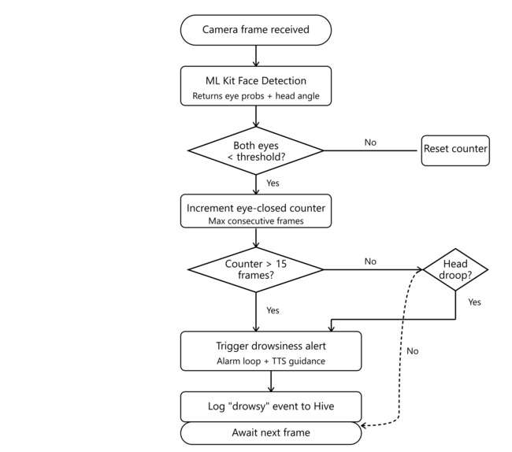
Figure 5 Drowsiness Detection Algorithm Diagram

5.2 External APIs

Table 16
Name of API | Description of API | Purpose of Usage | Function/Class Name
google_mlkit_face_detection | On-device face detection providing eye-openness probabilities and head Euler angles | Drowsiness and head-pose detection | DrowsinessScreen, YawnDetector
camera | Flutter camera plugin for live frame streaming | Provides image streams to ML Kit processor | DrowsinessScreen
audioplayers | Cross-platform audio playback | Plays looping alarm sound on drowsiness/accident detection | DrowsinessScreen, AccidentDetector
flutter_tts / TtsService | Text-to-speech synthesis | Audible guidance messages on alert events | TtsService
hive / hive_flutter | Lightweight local NoSQL database | Persists detection events for analytics | DatabaseService
permission_handler | Runtime permission management | Requests camera and location permissions | main.dart, SplashScreen
google_maps_flutter / map plugin | Google Maps SDK for Flutter | Displays nearby rest areas on map screen | MapScreen

5.3 User Interface
The application comprises five primary screens. The SplashScreen displays the application logo and performs asynchronous permission checks before routing to the HomeScreen. The HomeScreen presents navigation cards for the monitoring session, analytics, settings, and map modules. The DrowsinessScreen occupies the full viewport with a live camera preview and overlays status indicators for eye state, head pose, and yawn detection; alert banners appear at the top of the screen when fatigue is detected. The AnalyticsScreen renders a summary of logged events grouped by date and event type, with simple bar or count visualisations. The SettingsScreen provides toggle controls for sound and vibration and slider controls for detection sensitivity parameters. The MapScreen embeds an interactive map centred on the device's current GPS location with markers for nearby rest areas retrieved via the maps API.

5.4 Splash secreen
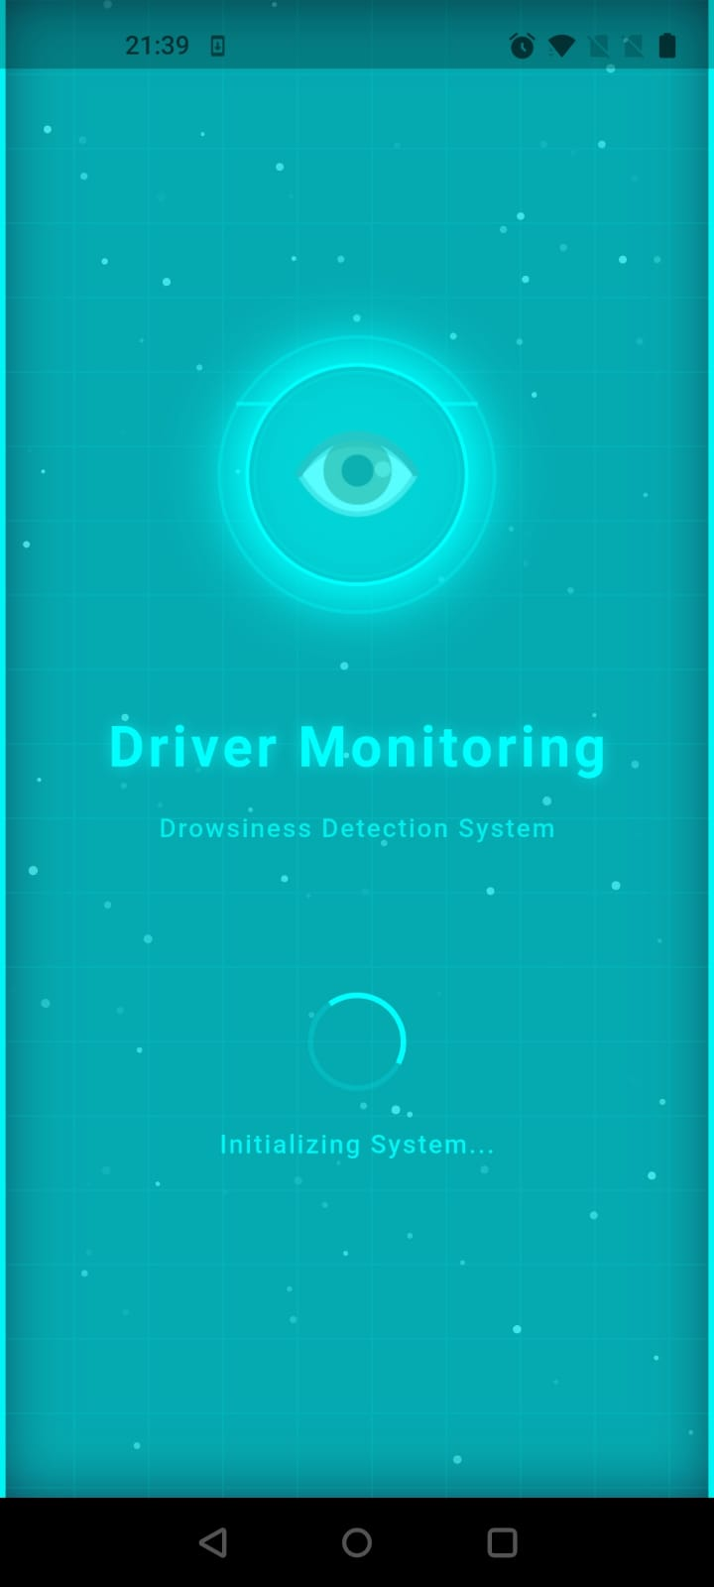
illustrates the Splash Screen of the AI-Powered Driver Monitoring and Assistance App. The screen serves as the initial entry point of the application, displaying the app logo centered on a dark background with neon blue accents. A circular loading indicator appears at the bottom of the screen while the system performs essential initialization tasks in the background Google ML Kit face detector setup.
Figure 6 splash Screen

5.5 Detection Screen
illustrates the Detection Screen of the AI-Powered Driver Monitoring and Assistance App. This is the core operational screen where real-time driver drowsiness monitoring takes place. The screen displays a live camera feed from the device's front-facing camera, with overlay elements showing real-time detection metrics and alert status.

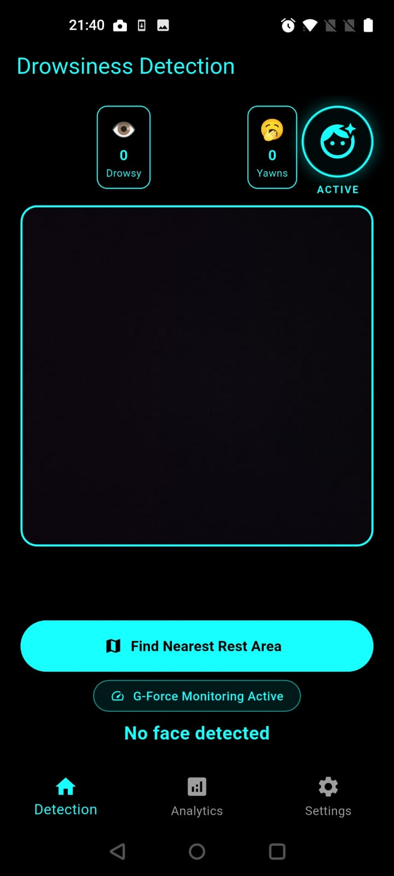
Figure 7 Detection Screen

5.6 Home Screen
illustrates the Home Screen of the AI-Powered Driver Monitoring and Assistance App. This screen serves as the central hub and primary entry point for all application features. The screen features a futuristic neon-accented design with a dark theme, displaying a personalized greeting, quick statistics summary, and navigation cards to all major modules.

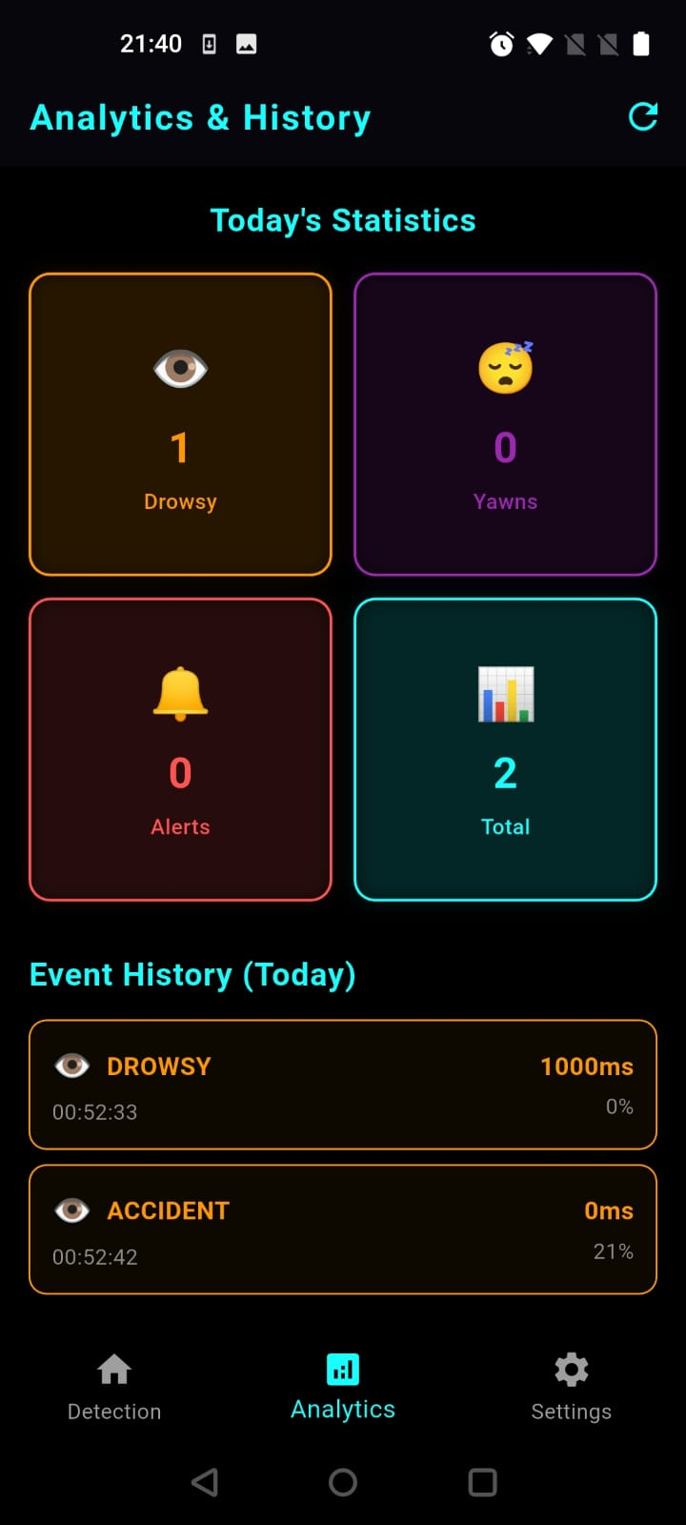
Figure 8: Home Screen

5.7 Settings Screen
illustrates the Settings Screen of the AI-Powered Driver Monitoring and Assistance App. This screen provides users with complete control over application behavior, detection sensitivity, emergency contacts, and notification preferences. The screen features a clean, organized layout with categorized sections for easy configuration.

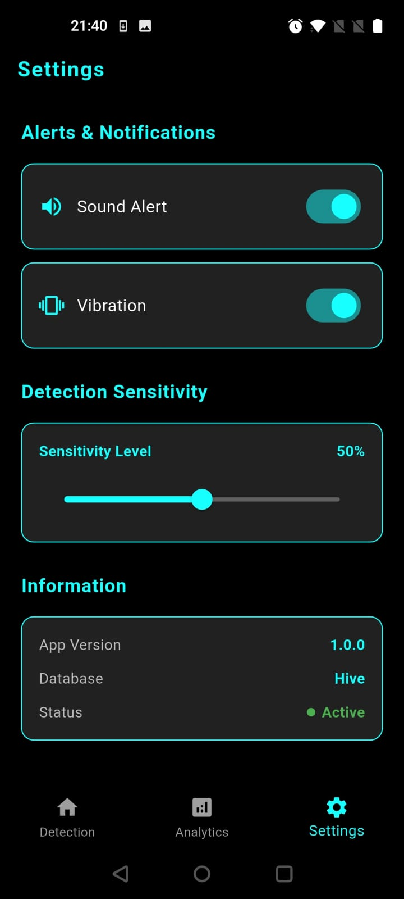
Figure 9: Settings Screen

Chapter 6

Testing and Evaluation

This chapter documents both manual and automated testing conducted to validate the application against its functional and non-functional requirements.

6.1 Manual Testing
Manual testing is performed to validate the functional and non-functional requirements of the AI-Powered Driver Monitoring and Assistance App. This testing approach involves human testers executing test cases without automation tools to identify bugs, usability issues, and ensure the application meets specified requirements.

6.1.1 System Testing
Once the application was successfully built and deployed to a physical Android device, end-to-end system testing was conducted to ensure that all modules operated in concert as intended. Testing scenarios included a complete monitoring session covering drowsiness detection, yawn detection, and simulated accident detection, as well as full navigation through all five application screens. No inter-module integration defects were identified after the final sprint.

6.1.2 Unit Testing
Unit Testing 1: Drowsiness Detection Threshold
Testing Objective: To verify that the drowsiness alert is triggered correctly when eye-closure frames exceed the threshold.

Table 17
No. | Test Case / Test Script | Attribute and Value | Expected Result | Result
1 | Hold both eyes closed in front of camera for threshold duration | Eye probability < 0.25 for 15 frames | Drowsiness alert triggered; alarm plays and TTS speaks | Pass
2 | Open eyes before threshold frame count is reached | Eye probability > 0.25 before 15 frames | No alert triggered; counter resets | Pass
3 | Droop head below configured angle threshold | headEulerAngleX < −20 degrees | Head-droop alert triggered | Pass

Unit Testing 2: Accident Detection
Testing Objective: To verify that the SOS flow activates on high-G-force input.

Table 18
No. | Test Case / Test Script | Attribute and Value | Expected Result | Result
1 | Simulate high G-force by sharply shaking the device | Resultant G-force > 2.5 g | SOS state activated; ACCIDENT DETECTED shown on screen | Pass
2 | Normal driving motion (phone resting on dashboard) | Resultant G-force < 2.5 g | No SOS triggered | Pass

6.1.3 Functional Testing
Functional Testing 1: Alert Sequence
Objective: To ensure that the correct alert modalities activate upon drowsiness detection.

Table 19
No. | Test Case / Test Script | Attribute and Value | Expected Result | Result
1 | Close eyes for sufficient duration to trigger alert | Both eye probabilities below threshold for 15 consecutive frames | Alarm sound begins looping; TTS guidance spoken; alert banner displayed | Pass
2 | Trigger yawn detection heuristic | Mouth-openness ratio exceeds yawn threshold | Yawn event logged; alert displayed | Pass
3 | Navigate to Analytics screen after session | Events stored in Hive database | Analytics screen shows drowsy, yawn, and accident event counts | Pass

6.1.4 Integration Testing

Table 20
No. | Test Case / Test Script | Attribute and Value | Expected Result | Result
1 | Launch app and grant camera permission | Permission granted | Drowsiness Screen camera preview loads successfully | Pass
2 | Complete monitoring session with mixed events | Drowsy + yawn + simulated accident | All three event types logged in Hive and visible on Analytics Screen | Pass
3 | Open MapScreen with location permission granted | GPS location acquired | Map centered on current location; rest area markers displayed | Pass
4 | Toggle sound off in Settings and trigger alert | Sound toggle set to OFF | Alert banner and TTS remain active; alarm sound suppressed | Pass

6.2 Automated Testing
Flutter's widget testing framework was used to test the rendering and interaction of individual screen widgets in isolation.

Table 21
Tool Name | Tool Description | Applied on / Results
Flutter Widget Test | Validates widget tree rendering and user interaction events without requiring a physical device | Settings Screen toggle interactions; Home Screen navigation card tap events FR-09, FR-10
Dart Unit Tests | Pure Dart logic tests for utility functions and threshold evaluation helpers | G-force magnitude calculation in Accident Detector; eye-closure counter logic FR-01, FR-06

6.3 Performance Analysis
This chapter documents the performance characteristics of the application observed during physical device testing. Measurements were taken on a mid-range Android device running Android 12 with 4 GB RAM. All performance observations are qualitative or semi-quantitative based on frame rate monitoring and manual timing, as the project scope did not include the integration of formal profiling tooling into the test pipeline.
The table below maps each performance-related non-functional requirement to the testing approach used to evaluate it and the observed result. NFR identifiers correspond to those defined in Section 3.4 of this report.
Table 22 Performance Observations Against Non-Functional Requirements
NFR ID | Requirement | Test Method | Observed Result
NFR-01 | Drowsiness detection latency shall not exceed 500 ms per frame. | Manual timing using device system clock timestamps logged at frame entry and ML Kit callback return. | Average processing time per frame: approximately 80-150 ms on the test device at ResolutionPreset.low. The _isProcessing mutex ensures frames are not queued, maintaining an effective detection rate of 6-10 FPS.
NFR-02 | Application shall operate without internet for core safety functions. | Network connection disabled on test device; full monitoring session conducted. | All drowsiness detection, yawn detection, accident detection, alert playback, and database logging functions operated correctly with no network connection. Only the MapScreen rest-area search failed, as expected.
NFR-07 | Local database operations shall complete within 100 ms. | Dart stopwatch measurements around addEvent() and getTodayEvents() calls logged to debug console. | addEvent() consistently completed in under 5 ms. getTodayEvents() with 50 records completed in under 10 ms. Both are well within the 100 ms requirement.
NFR-04 | Compatibility with Android 8.0 (API 26) and above. | Testing conducted on Android 12 (API 32). pubspec.yaml minSdkVersion set to 26. | No API-level-specific issues encountered on the test device. Camera and sensor APIs used are available from API 21 onwards.
NFR-03 | All facial analysis on-device; no biometric data transmitted externally. | Network traffic monitoring via Android developer tools during a full monitoring session. | Zero network requests attributable to face detection were observed during monitoring sessions. google_mlkit_face_detection operates entirely on-device.

6.4 Comparative Analysis with Related Systems
This chapter positions the Driver Monitoring and Assistance App in the context of existing driver drowsiness detection approaches documented in the literature and commercially available systems. The comparison highlights the distinctive contributions of this project and clarifies the design trade-offs that were made relative to alternative approaches.
The table below compares the proposed application against four reference systems: a CNN-based research prototype (Deng and Wu, 2019), a Vision Transformer-based system (Jarndal et al., 2024), a commercial OEM in-vehicle camera system, and a third-party dashcam-based solution. Comparison dimensions include deployment platform, processing location, accident detection capability, accessibility, and the availability of analytics.
Table 23 Comparison with Related Driver Monitoring Approaches
Feature | This Project | Deng & Wu CNN | Jarndal ViT | OEM In-Vehicle | Dashcam System
Platform | Android smartphone | PC/Server | PC/Server | Embedded ECU | Dedicated hardware
Processing | On-device (ML Kit) | GPU server | GPU server | On-device ECU | On-device
Eye Detection | Yes (ML Kit) | Yes (CNN) | Yes (ViT) | Yes (IR cam) | Varies
Yawn Detection | Yes (proxy) | Limited | Yes | Some models | No
Head Pose | Yes (Euler X) | No | Yes | Yes | No
Accident SOS | Yes (accelerometer) | No | No | Some models | No
Analytics | Yes (Hive) | No | No | No | Limited
Internet Required | No (core) | Yes | Yes | No | No
Cost / Access | Free (smartphone) | Lab only | Lab only | Premium vehicle | Hardware purchase
Privacy | Full (on-device) | Low | Low | Medium | Medium

6.4.1 Feature Completeness Comparison
While Table 15.1 summarises the high-level comparison, the following table provides a more granular feature-by-feature breakdown focusing on the specific fatigue indicators monitored, the alert mechanisms employed, and the post-event capabilities supported by each system category.
This table provides a detailed feature-level comparison across system categories. It demonstrates that while research systems may achieve higher detection accuracy through advanced models, they lack the real-world deployment capabilities and integrated safety features that this project delivers as a consumer-ready application.

Table 24 Granular Feature Completeness Matrix
Feature | This Project | CNN Research | ViT Research | OEM/Dashcam
Real-time eye closure detection | Yes | Yes | Yes | Yes (IR)
Head pose monitoring | Yes (Euler X) | No | Yes | Varies
Yawn detection | Yes (ML Kit proxy) | Limited | Yes | No
Microsleep detection | Via frame counter | Yes | Yes | Some
Accelerometer-based accident detection | Yes | No | No | No
TTS voice guidance | Yes | No | No | No
Audio alarm on detection | Yes (looping) | No | No | Some
Persistent event logging | Yes (Hive) | No | No | Some (cloud)
On-device analytics dashboard | Yes | No | No | Limited
Rest area navigation | Yes (Google Maps) | No | No | No
Sensitivity customisation | Yes (Settings) | No | No | No
Cross-platform (Android/iOS ready) | Yes (Flutter) | No | No | No
Zero cloud dependency for core safety | Yes | No | No | Yes
Open to customisation | Yes (source code) | Yes (research) | Yes (research) | No

Chapter 7

Conclusion and Future Work

7.1 Conclusion
The Driver Monitoring and Assistance App successfully demonstrates that a consumer smartphone, equipped with a front-facing camera and an accelerometer, can provide real-time drowsiness monitoring and accident-triggered emergency assistance without requiring cloud connectivity or dedicated hardware. The application achieves its primary objectives: it detects eye closure, head drooping, and yawning through Google ML Kit Face Detection; it responds with immediate audio-visual alerts; it detects high-G-force collision events and activates an SOS flow; and it persists all detection events for retrospective analysis.

The iterative agile methodology proved well-suited to the experimental nature of the project, allowing detection thresholds to be refined across successive sprints based on physical-device testing. The Flutter framework's cross-platform capability and its hot-reload feature substantially accelerated the development cycle. The application meets all defined functional requirements and satisfies the key non-functional requirements related to privacy, performance, and usability.

7.2 Detailed Future Work Roadmap
Section 7.2 of this report introduced the principal directions for future development. This chapter expands on those directions by specifying the technical approach, required dependencies, estimated complexity, and expected impact of each proposed enhancement. The roadmap is organised into short-term (within one additional sprint), medium-term (within three additional sprints), and long-term (beyond three sprints) categories.
Short-term enhancements are incremental improvements that can be delivered within a single two-week sprint without significant architectural changes. They primarily address known limitations identified during testing and evaluation of the current system.

Table 25 Short-Term Enhancement Roadmap (1 Sprint)
Enhancement | Technical Approach | Expected Impact
GPS speed-based false positive suppression for accident detection | Integrate geolocator speed property into AccidentDetector. Suppress accident event dispatch if GPS speed is below 10 km/h at time of G-force spike. | Eliminates false accident triggers caused by speed bumps, car door slams, and device drops while stationary.
Landmark-based mouth aspect ratio for yawn detection | Replace smilingProbability proxy with explicit mouth-landmark distance calculation using ML Kit face contour points (upper lip to lower lip distance divided by mouth width). | Improves yawn detection accuracy under variable lighting conditions and for users with atypical facial geometry.
Persistent settings storage | Replace in-memory toggle states in SettingsScreen with Hive box reads and writes. Persist sensitivityLevel, soundEnabled, and vibrationEnabled across app restarts. | User settings are retained between sessions, improving usability for repeat users.
Analytics trend chart | Integrate fl_chart or similar Flutter charting library to display a 7-day event frequency bar chart on the AnalyticsScreen. | Enables drivers and fleet supervisors to identify patterns of fatigue over multiple sessions, supporting behavioural intervention.

Medium-term enhancements require more substantial development effort and may involve new architectural components or platform-level integrations. Each enhancement in this category represents a significant feature addition rather than a refinement of existing functionality.

Table 26 Medium-Term Enhancement Roadmap (2-3 Sprints)
Enhancement | Technical Approach | Expected Impact
Automated SOS SMS with GPS coordinates | Integrate flutter_sms or telephony package. On confirmed accident detection, compose and send a pre-configured SMS containing device coordinates retrieved from geolocator to a saved emergency contact number. | Enables passive emergency notification when the driver is incapacitated, potentially reducing emergency response time significantly.
Custom TFLite drowsiness model integration | Train a binary eye-state classifier using the MRL Eye Dataset or similar labelled dataset. Convert to TensorFlow Lite format and integrate via tflite_flutter plugin, replacing or augmenting the ML Kit probability heuristic. | Improves eye-closure detection accuracy under challenging conditions such as users wearing glasses, low infrared lighting, or partial face occlusion.
Fleet management dashboard (web) | Develop a companion web application using Flutter Web or React that aggregates DatabaseService export files uploaded by multiple drivers. Display session statistics, fatigue trends, and event maps. | Enables commercial fleet operators to monitor driver safety across a vehicle pool, providing data-driven insights for driver scheduling and safety compliance.
iOS build and App Store submission | Configure iOS-specific permissions in Info.plist for camera and location. Test on physical iPhone hardware. Address any platform-specific UI or API differences in the camera and TTS modules. Prepare App Store listing and privacy policy. | Extends application reach to the significant iPhone user base, particularly relevant in markets where iOS penetration is high.

Long-term enhancements represent the vision for the application's evolution beyond its current scope. They require significant research, design, and development effort and may involve partnerships with external data providers or platform vendors. These enhancements are intended to position the application as a comprehensive intelligent driver safety platform.

Table 27 Long-Term Enhancement Roadmap (Beyond 3 Sprints)
Enhancement | Technical Approach | Expected Impact
Vision Transformer integration for high-accuracy fatigue detection | Research and adapt the ViT-based architecture described by Jarndal et al. (2024) for mobile deployment. Apply model quantisation and pruning techniques to reduce the model below 10 MB for on-device inference via TFLite. | Achieves state-of-the-art detection accuracy comparable to server-side research systems within a fully on-device deployment, as demonstrated in the literature.
Predictive fatigue scoring using historical data | Build a time-series model that analyses a driver's historical detection event patterns from the Hive database to generate a session-start fatigue risk score. Implement using a lightweight LSTM or rule-based scoring algorithm. | Enables proactive fatigue warnings before a session begins, based on the driver's personal fatigue pattern history.
OBD-II vehicle data integration | Integrate with On-Board Diagnostics II via a Bluetooth OBD adapter using the flutter_obd2 or equivalent package. Correlate engine RPM, speed, and vehicle lane position data with biometric fatigue signals. | Creates a multi-modal fatigue assessment system that is significantly more robust than camera-only or accelerometer-only approaches, reducing both false positives and false negatives.
Federated learning for personalised thresholds | Implement a federated learning framework in which each device trains a lightweight personal calibration model on its local event history without sharing raw data externally. Aggregated model updates improve the global default thresholds over time. | Enables the application to adapt its detection thresholds to individual users' physiological characteristics without compromising the on-device privacy model.

8 References

[1] Delwar, Tahesin Samira, et al. "AI-and deep learning-powered driver drowsiness detection method using facial analysis." Applied Sciences 15.3 (2025): 1102.
[2] W. Deng and R. Wu, "Real-Time Driver-Drowsiness Detection System Using Facial Features," in IEEE Access, vol. 7, pp. 118727-118738, 2019, doi: 10.1109/ACCESS.2019.2936663. keywords: {Vehicles;Fatigue;Face;Target tracking;Face recognition;Real-time systems;Correlation;convolutional neural network;fatigue detection;feature location;face tracking},
[3] Jarndal, Anwar, et al. "A real-time vision transformers-based system for enhanced driver drowsiness detection and vehicle safety." IEEE Access 13 (2024): 1790-1803.
[4] Jabbar, Rateb, et al. "Blockchain technology for intelligent transportation systems: A systematic literature review." IEEE Access 10 (2022): 20995-21031.
[5] Jarndal, Anwar, et al. "A real-time vision transformers-based system for enhanced driver drowsiness detection and vehicle safety." IEEE Access 13 (2024): 1790-1803.
[6] Fu, Biying, et al. "A survey on drowsiness detection–modern applications and methods." IEEE Transactions on Intelligent Vehicles (2024).

